SHELL Centre 1
Spring 2021 Timetable

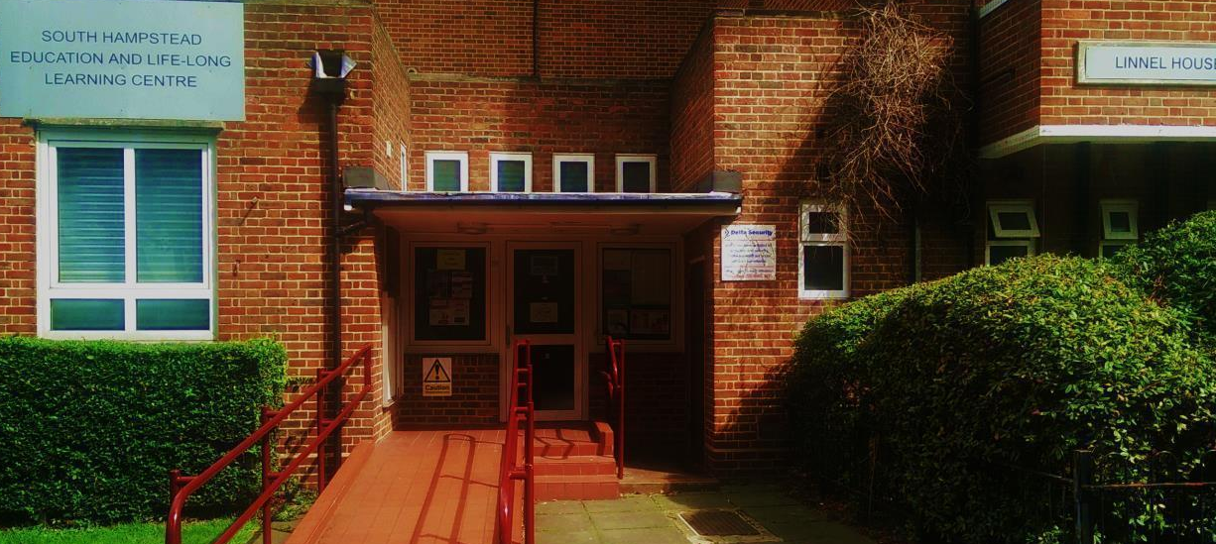
Linnel House, Boundary Road, London NW8 0HS
Tel: 020 7372 7021 / 07845448840
www.shakonline.co.uk email: shell@shakonline.co.uk
MONDAY | Preparing for Employment  Remote Support for job seekers- CV writing, online search, interview skills & confidence.  10am – 12pm***Please call or email to register***
TUESDAY | Preparing for Employment  10am – 12pm  Q&A About Preparing for Employment  1pm – 2pm Via Zoom ***Please call or email to register***
WEDNESDAY | Computer Skills For Work And Life  Remote Support for beginners – learn the basics of computers for work or fun! 10am – 12pm  CV Writing  1pm – 2pm Via Zoom***Please call or email to register***
THURSDAY | Interview Skills  1pm – 2pm Via Zoom***Please call or email to register***
FRIDAY | Computer Skills For Work And Life  10am – 12pm***Please call or email to register***
***Please turn over to see the Spring 2021 timetable for SHELL CENTRE 2***
Train stations: South Hampstead Overground, Kilburn Park, Swiss Cottage. Buses: 31, 139 & 189.All our courses, workshops, classes and activities are FREE for local residents! To find out more, please call 0207372702 or email shell@shakonline.co.uk
SHELL Centre 2
Spring 2021 Timetable

SHELL CENTRE 2
Fielding House, Boundary Road, London NW8 0HU
Tel: 020 7372 7021 / 07845448840
www.shakonline.co.uk
MONDAY | Online Healthy Eating Sessions  Learn how to make simple healthy dishes on a budget following Eat Well Guide  11am – 12pm starting 18th Jan 2021  ***Please call or email to register***
TUESDAY | Online English for Everyday E1, E2  10am – 12pm  Tai Chi via Zoom  10am – 11am***Please call or email to register***
WEDNESDAY
THURSDAY | Health & Wellbeing Cafe (Cultural Advocacy Project)  Raising awareness and promoting good mental health and wellbeing.  Share/listen to experiences in a friendly and welcoming group.  Online 11am - 12pm ***Please call or email to register***  SHAK Chef  Collect ingredients from us, Learn fun and simple recipes to cook with your family, Learn how to reduce waste and cook on a budget, Watch our cooking videos and share yours.  Online 3.30pm – 4.30pm ***Please call or email to register***
FRIDAY

